Zomato Restaurant
Project Summary: Zomato Market Analysis & "Star" Restaurant Identification
1. Project Objective
The goal of this project was to analyze the Zomato restaurant dataset to understand market behavior and identify key metrics that define a "star" restaurant. These insights were translated into an interactive, automated Tableau dashboard to serve as the foundation for a revamped B-to-C consolidator portal.
2. Preliminary Data Inspection (Week 1)
Using Python and Pandas, the dataset (9,551 records, 19 variables) underwent preliminary profiling and cleaning:
- Data Quality: Verified zero duplicate rows and handled minor missing values in the Cuisines and Restaurant Name columns.
- Geographical Spread: Identified a heavy market concentration in India, specifically New Delhi (5,473 restaurants), with the minimum representation being single-restaurant cities like Miller.
- Franchise Dominance: Cafe Coffee Day holds the highest national presence with 83 locations.
- Operational Ratios: The majority of restaurants operate traditionally; 87.9% do not offer table booking, and 74.3% do not offer online delivery.
- Engagement Metrics: Restaurants providing online delivery generate significantly higher customer engagement, averaging 211.3 votes compared to 138.1 for non-delivery venues.
3. Advanced Exploratory Data Analysis (Week 2)
Further statistical evaluation revealed clear drivers of restaurant ratings:
- Cuisine Processing: Applied text-processing techniques to explode and count complex cuisine arrays, identifying market saturation and demand per region.
- Value Tier Analysis: Restaurants operating at lower price points without table booking exhibit highly volatile ratings (ranging from 2.0 to 4.5).
- Premium Tier Analysis: Restaurants offering table bookings sit at a higher price bracket and consistently secure higher aggregate ratings (3.5+).
4. Interactive Dashboard Development
To operationalize these insights, the cleaned dataset was integrated into Tableau to build an intelligent recommendation matrix:
- Geospatial Mapping: Engineered a global density map using localized coordinates, sizing markers by engagement (votes) and applying a diverging color scale to instantly highlight high-rated locations.
- Performance Tracking: Constructed a scatter plot measuring Average Cost against Aggregate Rating, segmented by Table Booking.
- Dynamic Filtering: Applied currency and geographic filters to normalize cost data, alongside dashboard actions that allow stakeholders to seamlessly drill down into specific regional markets.

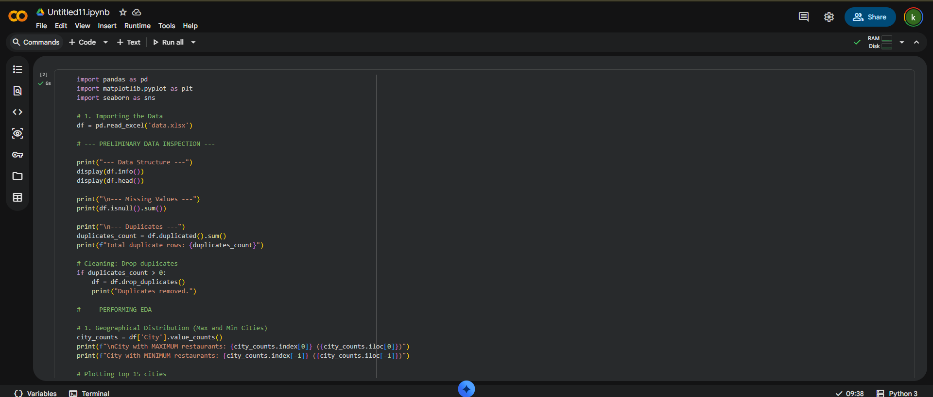

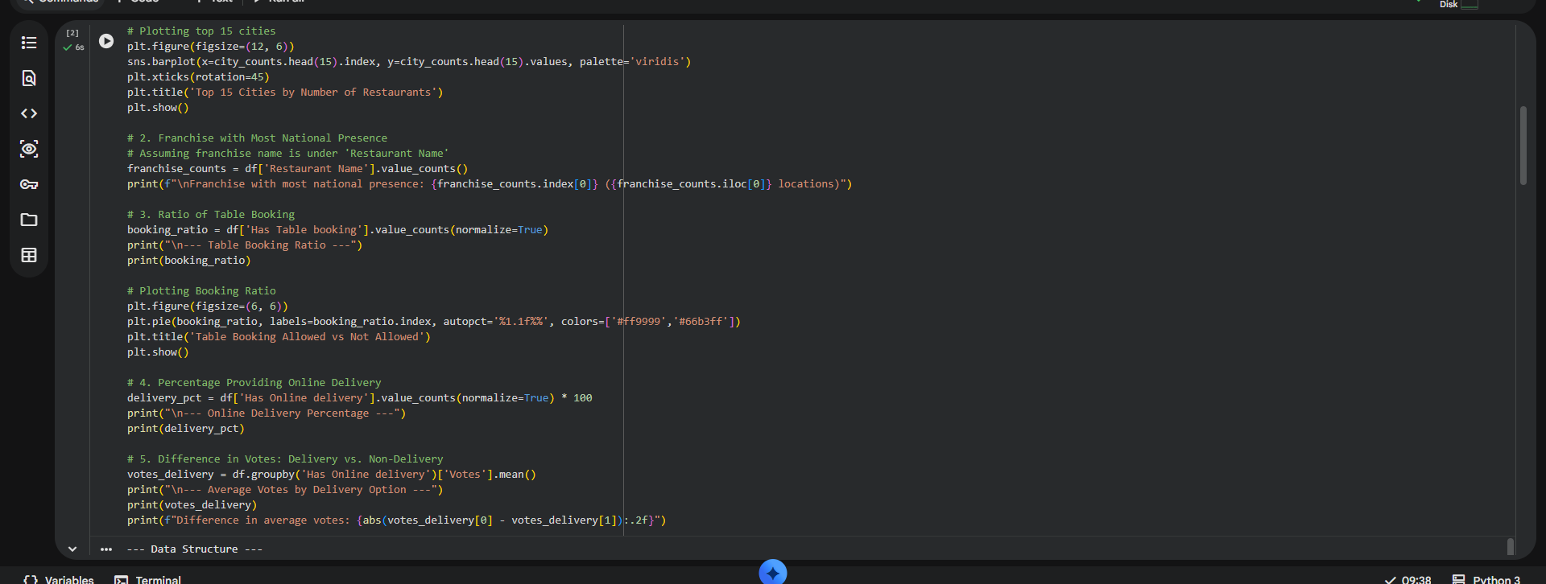

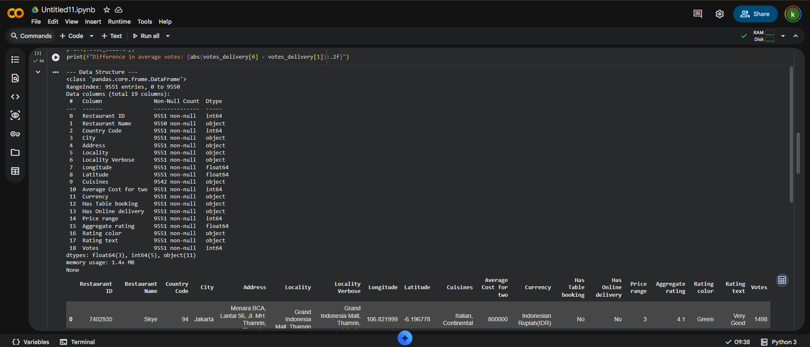

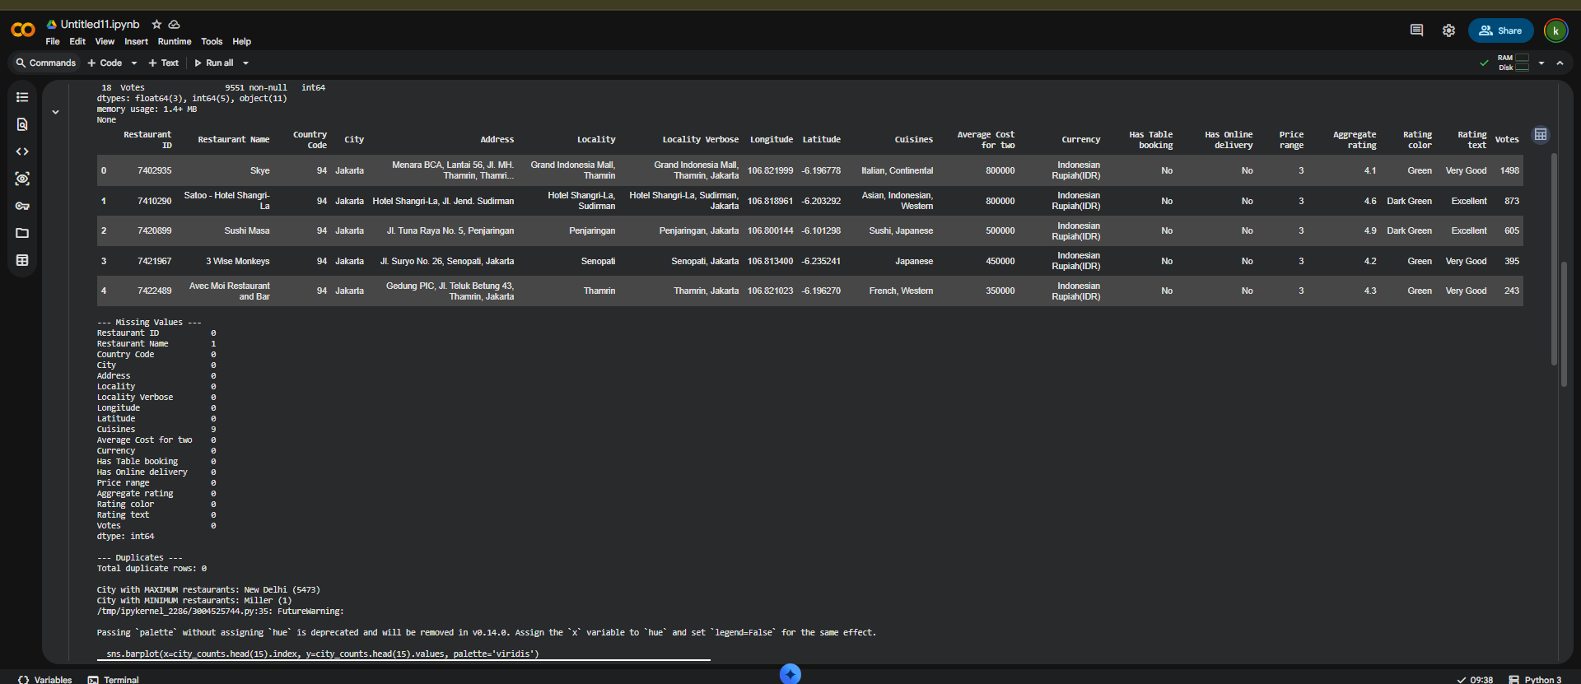

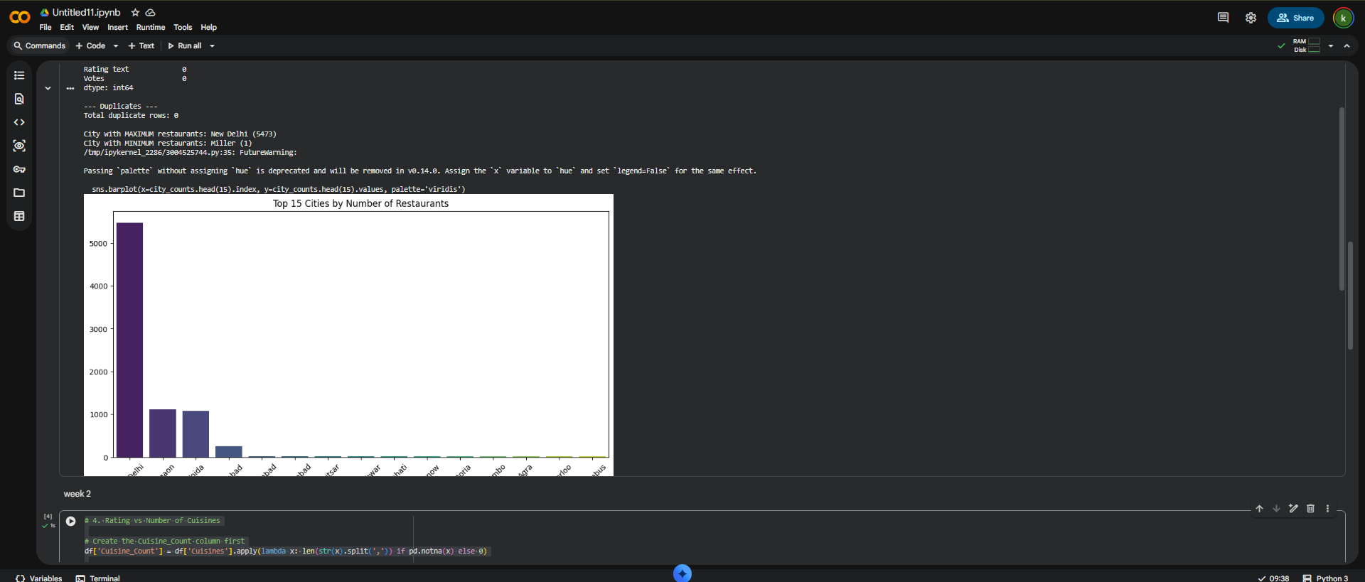

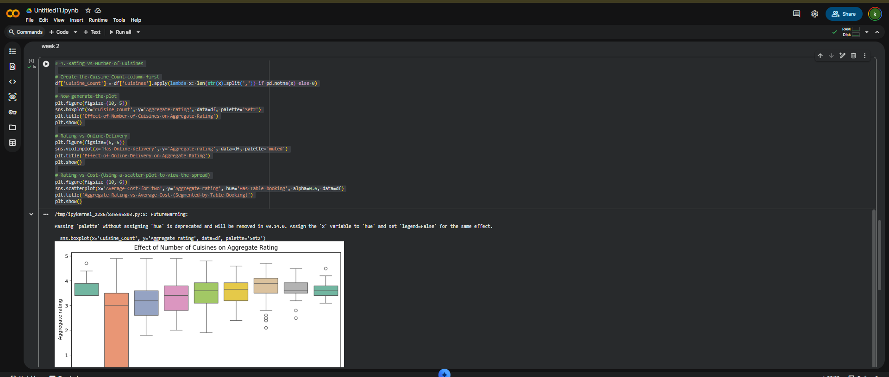

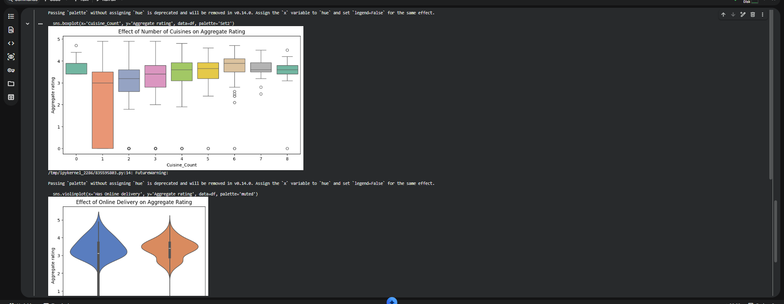

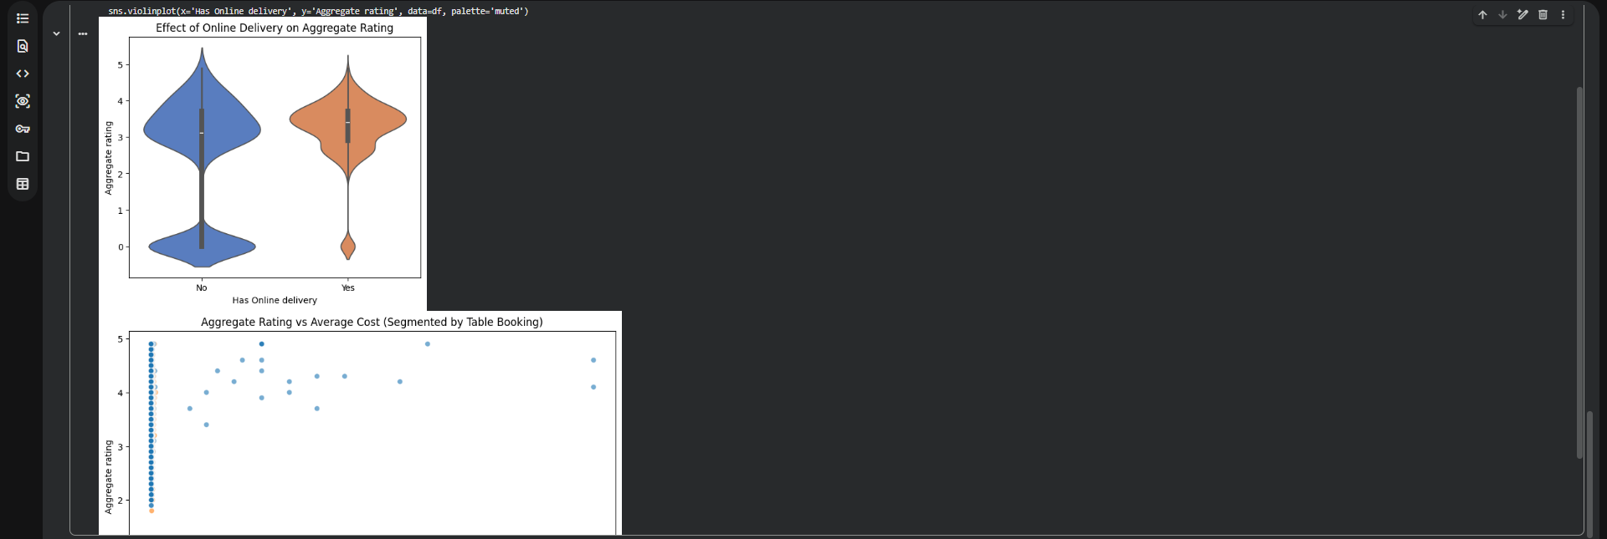

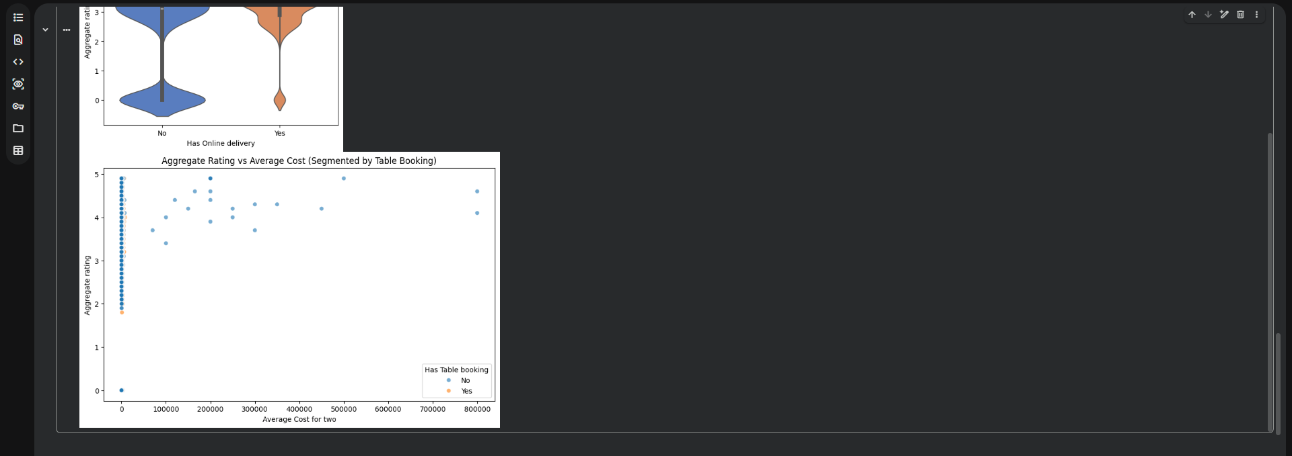

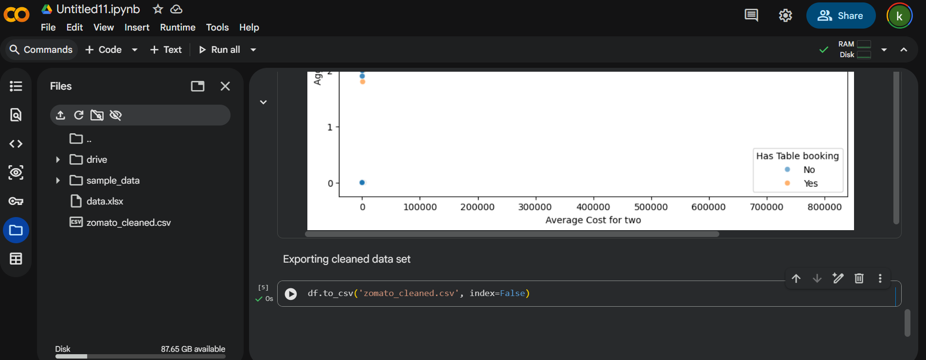
Tableau Dashboard
